# Blue Team: Summary of Operations

## Table of Contents

- Network Topology

- Description of Targets

- Monitoring the Targets

- Patterns of Traffic & Behavior

- Suggestions for Going Further

### Network Topology

The following machines were identified on the network:

* Kali
  + Operating System: Kali Release 2020.1 / Kernel: Linux 5.4.0
  + Purpose: Attacker/pen test machine
  + IP Address: 192.168.1.90
* ELK
  + Operating System: Ubuntu 18.04
  + Purpose: Elasticsearch & Kibana Stack
  + IP Address: 192.168.1.100
* Target 1
  + Operating System: Debian GNU/Linux 8/v3.16.0-6
  + Purpose: WordPress host
  + IP Address: 192.168.1.110
* Target 2
  + Operating System: Debian GNU/Linux 8/v3.16.0-6
  + Purpose: WordPress host
  + IP Address: 192.168.1.115
* Capstone
  + Operating System: Ubuntu 18.04
  + Purpose: The Vulnerable Web Server
  + IP Address: 192.168.1.105

### Description of Targets

The target of this attack was: Target 1 (192.168.1.110).

Two VMs on the network were vulnerable to attack due to weak security implementation services and administration: Target 1 (192.168.1.110) and Target 2 (192.168.1.115). However, only Target 1 is covered and was attacked.

Target 1 is an Apache web server and has SSH enabled, so ports 80 and 22 are possible ports of entry for attackers. As such, the following alerts have been implemented:

### Monitoring the Targets

Traffic to these services should be carefully monitored. To this end, we have implemented the alerts below:

**Excessive HTTP Errors**

Alert 1 is implemented as follows:

- **Metric**: WHEN count() GROUPED OVER top 5’http.response.status_code’

- **Threshold**: IS ABOVE 400

- **Vulnerability Mitigated**: Enumeration

- **Reliability**: The alert is highly reliable. Measuring by error codes 400 and above will filter out any normal or successful responses. 400+ codes are client and server errors that are of more concern. Especially when considering these error codes going off at a high rate. It detected our wpscan.

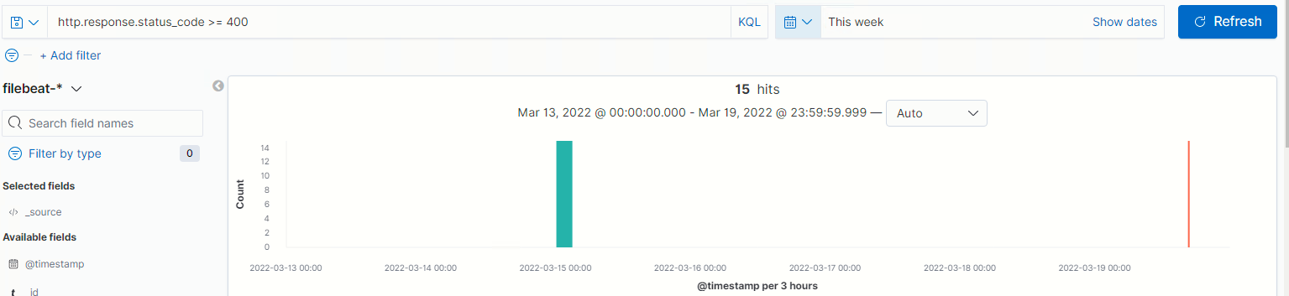

**HTTP Requst Size Monitor**

Alert 2 is implemented as follows:

- **Metric**: WHEN sum() of http.request.bytes OVER all deocuments

- **Threshold**: IS ABOVE 3500

- **Vulnerability Mitigated**: Measurement of high traffic events; which could be an indicator of attack.

- **Reliability**: This was highly reliable when John the Ripper was executed.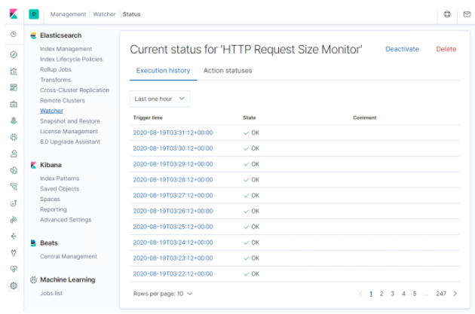

CPU Usage Monitor

CPU Usage Monitor is implemented as following

- **Metric**: WHEN max () OF system.process.cpu.total OVER all documents

- **Threshold**: IS ABOVE 0.5

- **Vulnerability Mitigated**: john the ripper

- **Reliability**: Low and unreliable; the cpu usage monitor triggered even when not attacked

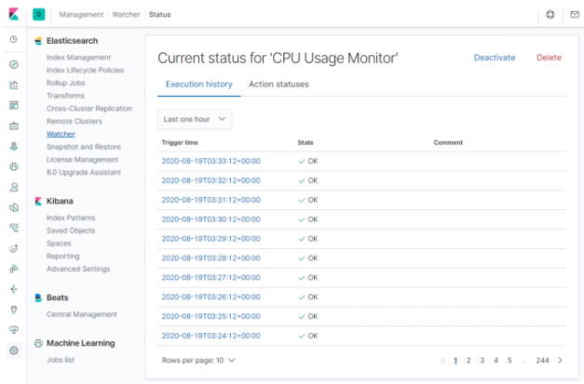

### Suggestions for Going Further

Suggest a patch for each vulnerability identified by the alerts above. Remember: alerts only detect malicious behavior. They do not prevent it. It is not necessary to explain how to implement each patch.

The logs and alerts generated during the assessment suggest that this network is susceptible to several active threats. In addition to watching for occurrences of such threats, the network should be hardened against them. The Blue Team suggests that IT implement the fixes below to protect the network:

Excessive HTTP Errors

* Patch: WordPress Hardening
  + Implement regular updates to WordPress
    - WordPress Core
    - PHP version
    - Plugins
  + Install security plugin(s)
    - Ex. Wordfence (adds security functionality)
  + Disable unused WordPress features and settings like:
    - WordPress XML-RPC (on by default)
    - WordPress REST API (on by default)
  + Block requests to /?author= by configuring web server settings
  + Remove WordPress logins from being publicly accessible specifically:
    - /wp-admin
    - /wp-login.php
* Why It Works:
  + Regular updates to WordPress, the PHP version, and plugins are an easy way to implement patches or fixes to exploits/vulnerabilities.
  + Depending on the WordPress security plugin it can provide things like:
    - Malware scans
    - Firewall
    - IP options (to monitor/block suspicious traffic)
  + REST API is used by WPScan to enumerate users
    - Disabling it will help mitigate WPScan or enumeration in general
  + XML-RPC uses HTTP as its method of data transport
  + WordPress links (permalinks) can include authors (users)
    - Blocking requests to view all authors (users) helps mitigate against user enumeration attacks
  + Removal of public access to WordPress login helps reduce the attack surface

HTTP Request Size Monitor

* Patch: Code Injection/DDOS Hardening
  + Implementation of HTTP Request Limit on the webserver
    - Limits can include a number of things:
      * Maximum URL Length
      * The maximum length of a query string
      * Maximum size of a request
  + Implementation of input validation on forms
* Why It Works:
  + If an HTTP requests URL length, query-string, and oversize limit of the request a 404 range of errors will occur.
    - This will help reject these requests that are too large.
  + Input validation can help protect against malicious data anyone attempts to send to the server via the website or application in/across an HTTP request.

CPU Usage Monitor

* Patch: Virus or Malware hardening
  + Add or update to a good antivirus.
  + Implement and configure Host Based Intrusion Detection System (HIDS)
    - Ex. SNORT (HIDS)
* Why It Works:
  + Antiviruses specialize in the removal, detection, and overall prevention of malicious threats against computers.
    - Any modern antivirus usually covers more than viruses and is a robust solution to protecting a computer in general.
  + HIDS monitors and analyzes the internals of computing systems.
    - They also monitor and analyze network packets.